# **Checkpoint 1-** Life Below Water

# Design ideas:

### Group members

|  |
| --- |
| Hande Eda Ozdemir - 25357673 |
| Htet Oo Khin - 24254215 |
| Menomi Gamage - 25376776 |

### Colour Scheme

#80B9C8 (background colour)

#247D7F (font colour)

### Google fonts

Title - Stack Sans Notch

Body (content) - Roboto Flex



Extra font - Barlow

### Inspiration

|  |  |  |
| --- | --- | --- |
|  |  |  |

Inspiration - <https://globalgoals.org/goals/14-life-below-water/>

## Sitemap of website:

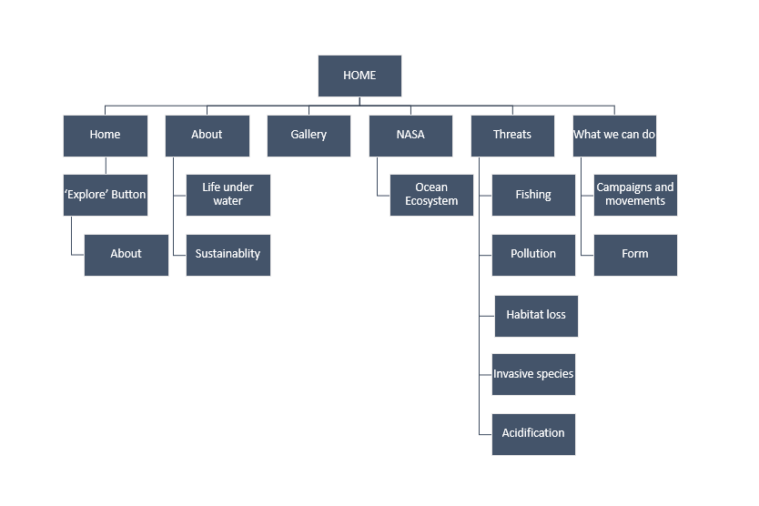

## Wireframes:

Home Page;

About Page;

Threats Page;

|  |  |
| --- | --- |
| Desktop Version | Mobile Version |
|  |  |

What can we do Page;

|  |  |
| --- | --- |
| Desktop version | Mobile version |
|  |  |

Gallery Page

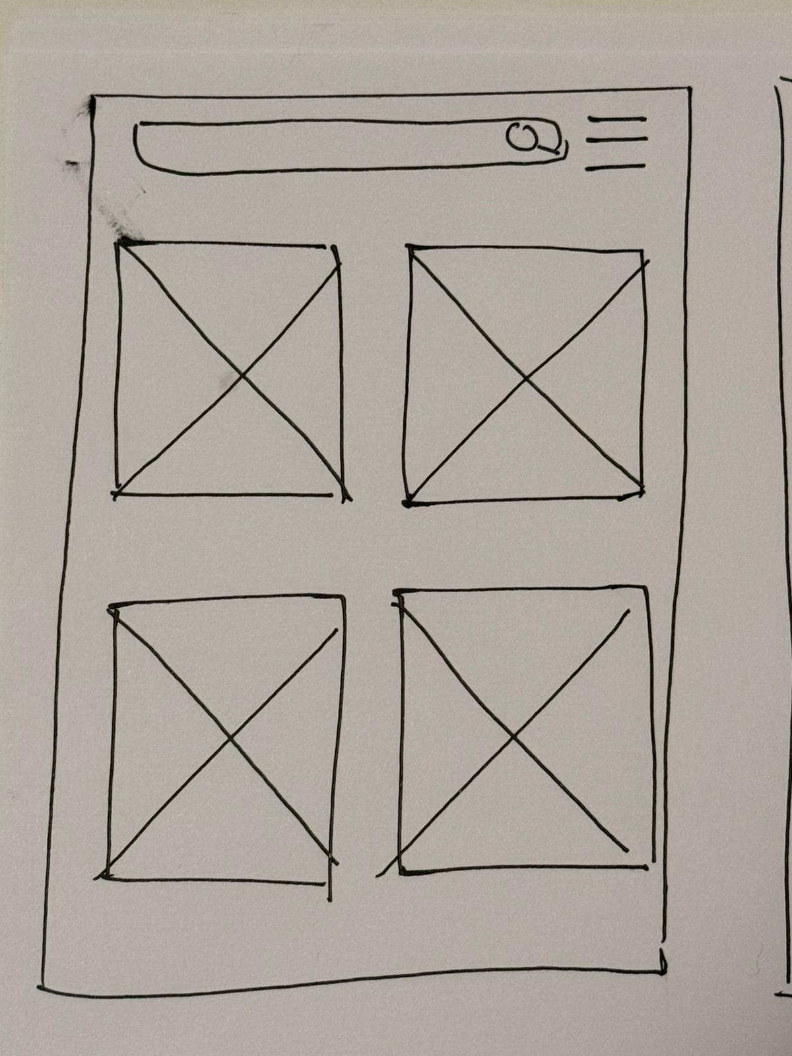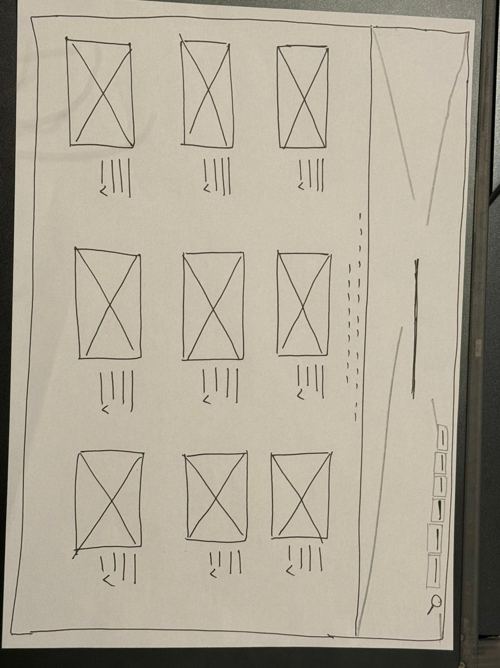

(Mobile view) (Desktop view)

NASA Page

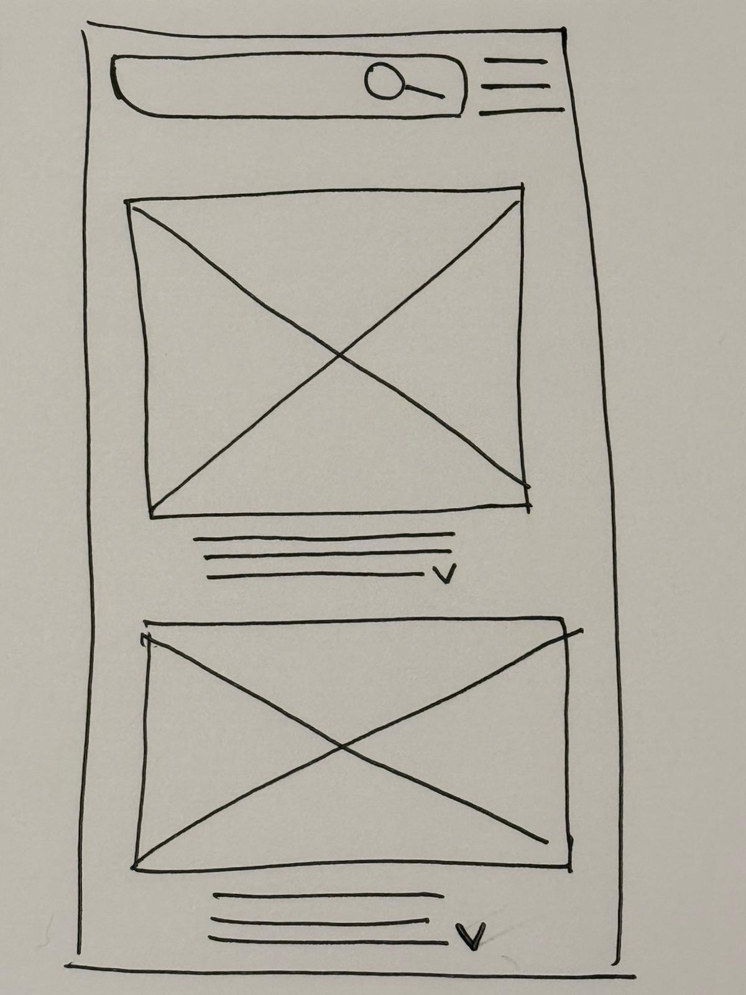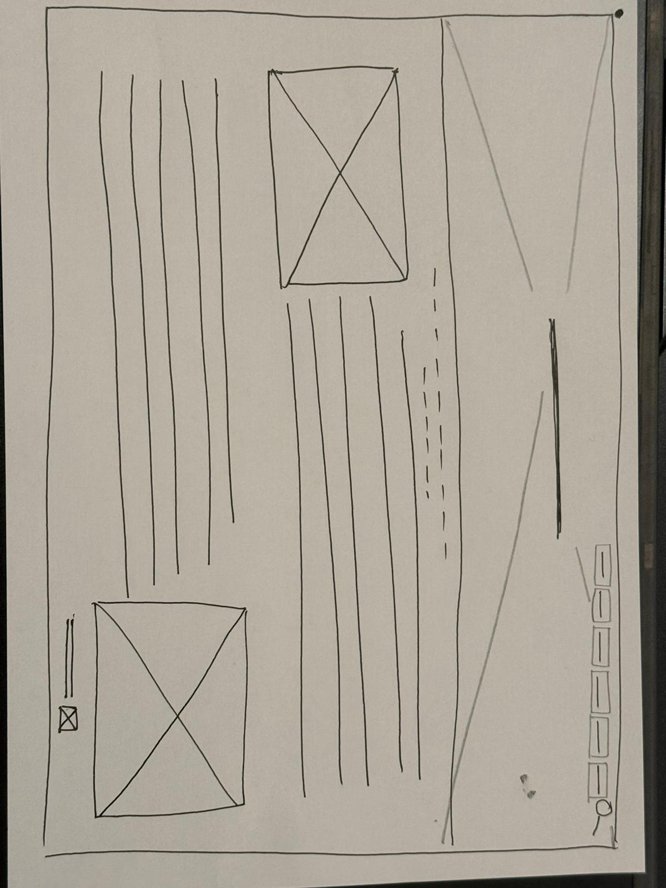

(Mobile view) (Desktop view)

## Excel sheet of tasks broken down:

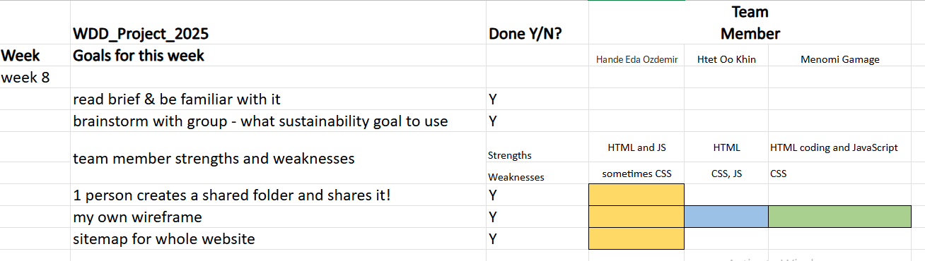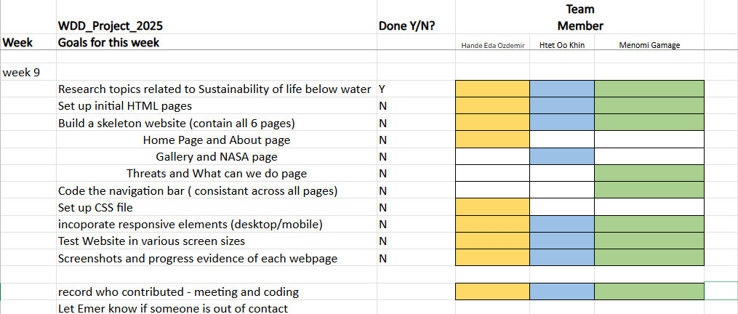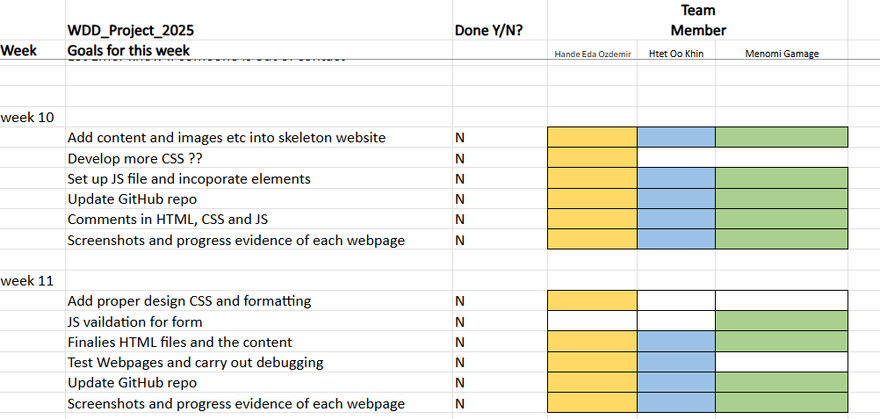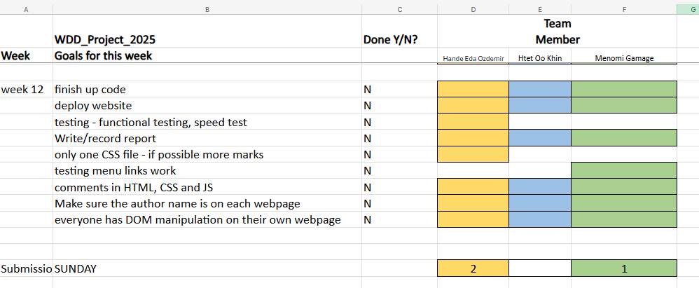

## GitHub link to repos:

Eda - <https://github.com/handeedaoz/WDD_GroupQ.git>

Menomi - <https://github.com/Meno20/Group-Q--Web-design-MenomiGamage-.git>

Htet Oo Khin - <https://github.com/htetookhin/WDD-Project.git>

## References

<https://www.picoanalytics.co.uk/insights/category/Life+Below+Water>

<https://www.17goalsmagazin.de/en/sustainability-goals/sdg-14-life-below-water/>

<https://www.wwf.eu/?360550/Failing-SDG14-EU-on-a-cliff-edge-for-ensuring-a-sustainable-ocean>